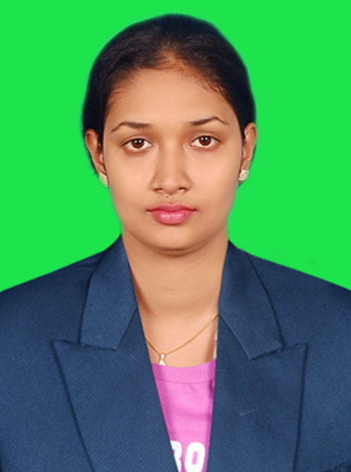
CURRICULAM VITAE

ARCHANA SAHANY

E-MAIL: archana.sahany@gmail.com

MOB.: 7873424917

CAREER OBJECTIVE
To obtain a position as a Manager of Human Resources that will utilize my experience, knowledge and skills to fulfill the needs, goals, vision and mission of the company.

CAREER Profile

- Have experience in Human Resource Arena and have acquired know-how in the areas like Recruitment & Selection, Induction, Performance Appraisal, Training needs, Compensation & Benefits, Provident Fund (PF),Attendance Management,Employee database management,Salary Management.
- Be candid and honest, but also have the wisdom to be diplomatic when required
- Highly flexible and adaptable contributor .
- Skilled leader with the ability to develop teamwork and achieve superior results
- Resourceful, goal oriented, possess strong organizational, communication and analytical skills with ability to work under pressure and multi task in a fast paced environment.

- Facilitating Recruitment and Induction.

PROFESSIONAL QUALIFICATION
- MBA-HR (2010-2012) From NIST,Berhampur,BPUT, Orissa.

Professional Experience
Executive-HR(Amass Multiagroindustries Ltd. Bhubaneswar)(1-year)
HR/Admin (Shadow Advertising Communication Pvt.Ltd.)(1-year)

PRESENT EMPLOYMENT Klonsys Techno Services PVT. LTD.
Currently working with Klonsys Techno Services Pvt. Ltd. as HR Executive since 1 year .Klonsys is in business with digital marketing..Klonsys handles many project with it’s foreign clients.Its employee strength is 30.

JOB RESPONSIBILITY :

- Analysis of manpower Requirement.

- Drafting ads, screening CV’s and maintaining records co-ordination with placement agencies
- Involved in full recruiting life cycle & end to end recruitment.

- -Understanding client requirements and deciding on the recruitment strategy.
- -Interacting with the delivery team on regular basis and prioritizing requirements as per the billable effective dates.

- -Sourcing CVs from various channels such as referencing, company’s own database, Job Portals ie.Indeed, Monster, Naukri, and networking tools such as Linkedin,Indeed.,Facebook.

- Taking HR Round Interview & Salary negotiation
- Maintained Database and Personnel File
-- Prepared offer and appointment letters,Experience letter,Releaving Order.

- Wage compensation structure –administration, fixation & Negotiation.
- Prepared Job description

- Assisting in framing, analyzing and revising the existing HR policies
- Co coordinating in Pay Roll Compensation, attendance & maintaining the Leave record of the employee

- Maintained resignation records, ex-employee dues; processed resignations with respective department heads;

- Processed the Exit Interview, full & final settlement and released Service Certificates after ensuring that the employees owed no dues
- Involvement in the Welfare Policies like Anniversary & Birth day Gift Distribution, Reward & Recognition etc

Academics Qualification

MBA (MASTER IN BUSINESS ADMINISTRATION) in 2012 from National Institute of Science and Technology (NIST), Berhmpur, under B.P.U.T. Rourkela, Odisha with specialization of HR and Marketing with 6.9 CGPA

BCA(BACHALOR IN COMPUTER APPLICATION) in 2010 from BCCM,Bhanjanagar under Berhampur University with 74%

INTERMEDIATE (SCIENCE) in 2007 from Bellaguntha science college Bellaguntha, under C.H.S.E. Board, Odisha with 59%.

MATRICULATION in 2005 from Govt. Girls’ High School Bellaguntha, under H.S.C.E Board, Odisha with 67%.

Computer Skills
- Basics (MS-Words, MS-PowerPoint, MS-Excel) Internet Concepts

INTERST & ACTIVITIES

- Comfortable in all Areas of HR / Personnel
- Meeting People and Communicating
- Wanna to walk some extra miles for achieve excellence
- Yoga & Meditation
- Workaholic

PERSONAL OVERVIEWS

- Highly motivated & self Driven
- Readiness to face challenges
- Effective Communication Skill
- Willingness to learn
- A good communication and strong team player
- Strong organizing capabilities & good at people skills
- Decision making abilities & strong believer in work

PERSONAL DETAILS

Permanent Address :At/po-Main Road
Bellaguntha,Ganjam, PIN-761119
DOB : 29TH October 1989
Gender : Female
Marital Status : Single
Nationality : Indian

DECLARATIONS

I guarantee you that my managerial & Technical skill & Experience will be distinctive competency resources to your organization

I am willing to meet you, if you need further clarification about my resume
Thanking you in anticipation

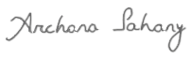

COMPUTER SKIL

Signature

